Príloha k uzneseniu 77.10.2
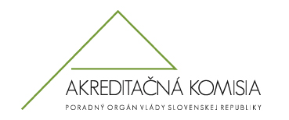

5 Main Challenges of Quality Assurance
in the Area of Higher Education in the Slovak Republic

- Methodical and other relevant support to HE institutions (in their efforts to develop and practice self-evaluation and other measures of internal QA processes that will also include student´ s participation).

- More demanding evaluation of HE institutions (higher quality standards – including the regard of graduate´s quality).

- Conduct regular, nationally-designed research of quality of HE institutions and to adopt a comparative perspective in it.

- Identify and support top quality individuals, teams and institutions within the HE in Slovakia.

- Support tendencies to reduce quantity of HE institutions and programs in Slovak HE sector.

